電通二乙微處理器實驗 實驗結報

實驗名稱 | Lab02-跑馬燈
組別 | 18 | 組員 | 王新喬

- 實驗目的
利用Ardino 7697 的接腳接到LED，做出題目所規定跑馬燈
- 實驗步驟
實驗一 :
1.LED 向左及向右執行花色展示
2. 執行自定花色展示:左移八次 -> 右移八次
實驗二 :
1.LED 向左及向右執行花色展示
2. 執行自定花色展示: 所有LED亮滅兩次 -> 左移八次 -> 所有LED亮滅兩次 -> 右移八次
實驗三 :
1. Arduino 接上一個開關
2. 開關 OFF -> LED 向左及向右執行花色展示
3. 開關 ON -> 執行自定花色展示

- 程式碼

// Lab02_1
// 使用for迴圈的跑馬燈程式
// 左移八次 -> 右移八次
// 每個 LED 正極接到 Pin10 - 7, 負極接地
const byte startPin = 10;

const byte endPin = 17;
byte i;
byte n;
void setup()
{
// 將每個 Pin 設定成輸出
for (byte i = startPin; i<= endPin; i++)
{
pinMode(i, OUTPUT);
}
}

void loop()
{
for (i=startPin;i<=endPin;i++)
digitalWrite(i, LOW);

for (i=startPin;i<=endPin;i++)
digitalWrite(i, LOW);
for (i=endPin;i>=startPin;i--)
{

digitalWrite(i, HIGH);
delay(100);

digitalWrite(i, LOW );
delay(100);
}

for (i=startPin;i<=endPin;i++)
{

digitalWrite(i, HIGH);
delay(100);

digitalWrite(i, LOW );
delay(100);
}
}
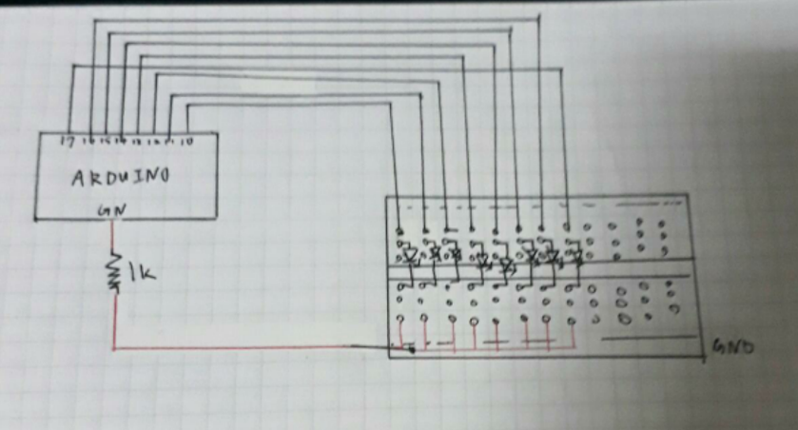

// Lab02_2
// 使用for迴圈的跑馬燈程式
//執行自定花色展示: 所有LED亮滅兩次 -> 左移八次 -> 所有LED亮
//滅兩次 -> 右移八次
// 每個 LED 正極接到 Pin1 0 - 7, 負極接地
const byte startPin = 10;

const byte endPin = 17;
byte i;
byte n;
void setup()
{
// 將每個 Pin 設定成輸出
for (byte i = startPin; i<= endPin; i++)
{
pinMode(i, OUTPUT);
}

}

void loop()
{
for (i=startPin;i<=endPin;i++)
digitalWrite(i, LOW);
//輛滅
digitalWrite(10, HIGH);
digitalWrite(11, HIGH);
digitalWrite(12, HIGH);
digitalWrite(13, HIGH);
digitalWrite(14, HIGH);
digitalWrite(15, HIGH);
digitalWrite(16, HIGH);
digitalWrite(17, HIGH);
delay(100);
digitalWrite(17, LOW);
digitalWrite(16, LOW);
digitalWrite(15, LOW);
digitalWrite(14, LOW);
digitalWrite(13, LOW);
digitalWrite(12, LOW);
digitalWrite(11, LOW);
digitalWrite(10, LOW);
delay(100);
//輛滅
digitalWrite(10, HIGH);
digitalWrite(11, HIGH);
digitalWrite(12, HIGH);
digitalWrite(13, HIGH);
digitalWrite(14, HIGH);
digitalWrite(15, HIGH);
digitalWrite(16, HIGH);
digitalWrite(17, HIGH);
delay(100);
digitalWrite(17, LOW);
digitalWrite(16, LOW);
digitalWrite(15, LOW);
digitalWrite(14, LOW);
digitalWrite(13, LOW);
digitalWrite(12, LOW);
digitalWrite(11, LOW);
digitalWrite(10, LOW);
delay(100);
//輛滅結束
for (i=startPin;i<=endPin;i++)
digitalWrite(i, LOW);
for (i=endPin;i>=startPin;i--)
{

digitalWrite(i, HIGH);
delay(100);

digitalWrite(i, LOW );
delay(100);
}
//輛滅
digitalWrite(10, HIGH);
digitalWrite(11, HIGH);
digitalWrite(12, HIGH);
digitalWrite(13, HIGH);
digitalWrite(14, HIGH);
digitalWrite(15, HIGH);
digitalWrite(16, HIGH);
digitalWrite(17, HIGH);
delay(100);
digitalWrite(17, LOW);
digitalWrite(16, LOW);
digitalWrite(15, LOW);
digitalWrite(14, LOW);
digitalWrite(13, LOW);
digitalWrite(12, LOW);
digitalWrite(11, LOW);
digitalWrite(10, LOW);
delay(100);
//輛滅
digitalWrite(10, HIGH);
digitalWrite(11, HIGH);
digitalWrite(12, HIGH);
digitalWrite(13, HIGH);
digitalWrite(14, HIGH);
digitalWrite(15, HIGH);
digitalWrite(16, HIGH);
digitalWrite(17, HIGH);
delay(100);
digitalWrite(17, LOW);
digitalWrite(16, LOW);
digitalWrite(15, LOW);
digitalWrite(14, LOW);
digitalWrite(13, LOW);
digitalWrite(12, LOW);
digitalWrite(11, LOW);
digitalWrite(10, LOW);
delay(100);
//輛滅結束
for (i=startPin;i<=endPin;i++)
{

digitalWrite(i, HIGH);
delay(100);

digitalWrite(i, LOW );
delay(100);
}

}

// Lab02_3
// 使用for迴圈的跑馬燈程式
//開關 OFF -> LED 向左及向右執行花色展示
// 開關 ON -> 執行自定花色展示
// 每個 LED 正極接到 Pin 10 - 7, 負極接地
const byte startPin = 10;

const byte endPin = 17;
byte i;
byte n;
void setup()
{
// 將每個 Pin 設定成輸出
for (byte i = startPin; i<= endPin; i++)
{
pinMode(i, OUTPUT);
}
pinMode(8, INPUT);
}

void loop()
{
if(digitalRead(8))
{
for (i=startPin;i<=endPin;i++)
digitalWrite(i, LOW);

for (i=startPin;i<=endPin;i++)
digitalWrite(i, LOW);
for (i=endPin;i>=startPin;i--)
{

digitalWrite(i, HIGH);
delay(100);

digitalWrite(i, LOW );
delay(100);
}

for (i=startPin;i<=endPin;i++)
{

digitalWrite(i, HIGH);
delay(100);

digitalWrite(i, LOW );
delay(100);
}
}
else
{
//輛滅
digitalWrite(10, HIGH);
digitalWrite(11, HIGH);
digitalWrite(12, HIGH);
digitalWrite(13, HIGH);
digitalWrite(14, HIGH);
digitalWrite(15, HIGH);
digitalWrite(16, HIGH);
digitalWrite(17, HIGH);
delay(100);
digitalWrite(17, LOW);
digitalWrite(16, LOW);
digitalWrite(15, LOW);
digitalWrite(14, LOW);
digitalWrite(13, LOW);
digitalWrite(12, LOW);
digitalWrite(11, LOW);
digitalWrite(10, LOW);
delay(100); }
//輛滅結束

}

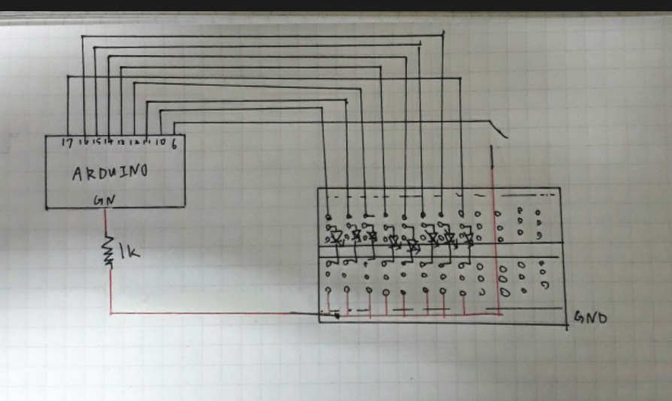
- 實驗結果及分析
每個人都用不同的方法 雖然大家得程式都不同 但都成功的達到效果
第三題因為沒有發開關 所以花了一些時間去想 但也成功達成了

- 心得討論
第一次使用arduino 雖然非常不熟悉 但程式還是成功地打完了 也成功地執行達題目所要求結果 希望之後能越來越熟練 程式也不要再打錯了

